PON NORWEGIAN ARM

3500 engines
For 3500 engines we have two available mounting options.

Base mount 1, to be center mounted. Needs removal of aftercooler core. Fits mechanical and electronic engines. Can also be installed in both front and rear end of engine AC for lifting of front/rear housing, flywheel, vibration damper, turbochargers etc.

Base mount 2, to be mounted on the front housing. Can be used on right or left hand side. The base can be tilted +/- 15 degrees.

For base mount 1, this has WLL400kg and maximum swing arm length is 1795 mm.

For base mount 2, this has WLL125kg and maximum swing arm length is 2495 mm.
Both 3500 base mounts can be used at the same time. This gives the opportunity for two engineers to work with one arm each at the same time.

C32 engines
For C32 engines we have a base mount that can be used in front of the engine. The front engine lifting eye need to be removed to install base mount 3. This base mount has WLL400kg and maximum swing arm length 1795 mm.

For ordering, you can put together the combination of base mounts, arms, shafts and joints to your own need.

An ordered set will be delivered with all necessary documentation, CE-marking, certified for one year and all parts needed for assembly and use.

Optional parts for delivery:
Air hoist, 250 kg, 6m lifting height
Air hoist, 500 kg, 3m lifting heigt
3500 cylinder liner lifting tool
Tool box, special designed

3500 center mounting
WLL400 kg, max arm 1795 mm
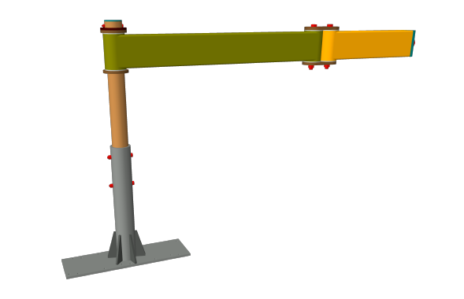

3500 front mounting
WLL125 kg, max arm 2495 mm
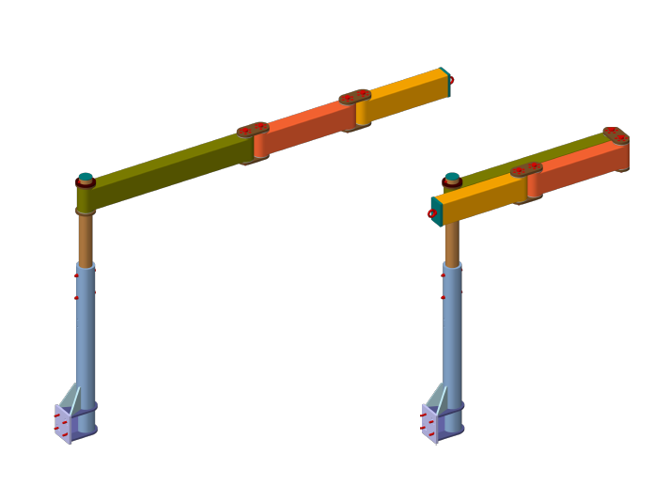

C32 front mounting
WLL400 kg, max arm 1795 mm
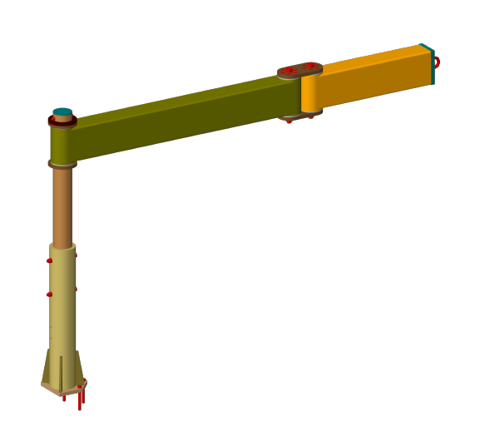

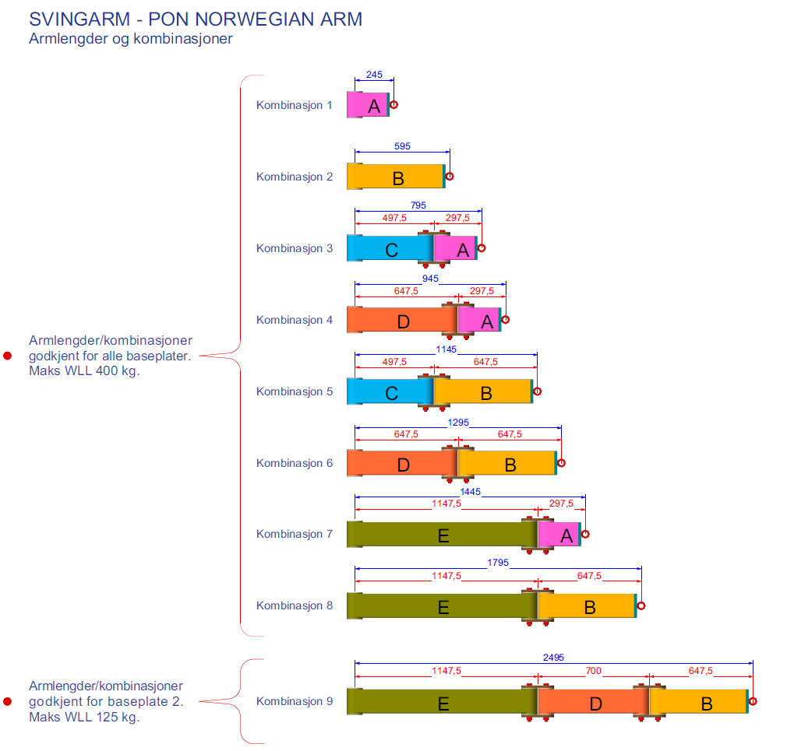

3500 center mounting

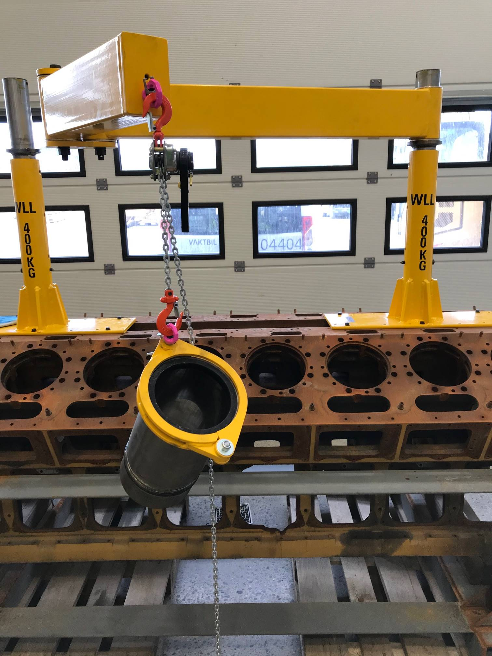

3500 front mounting

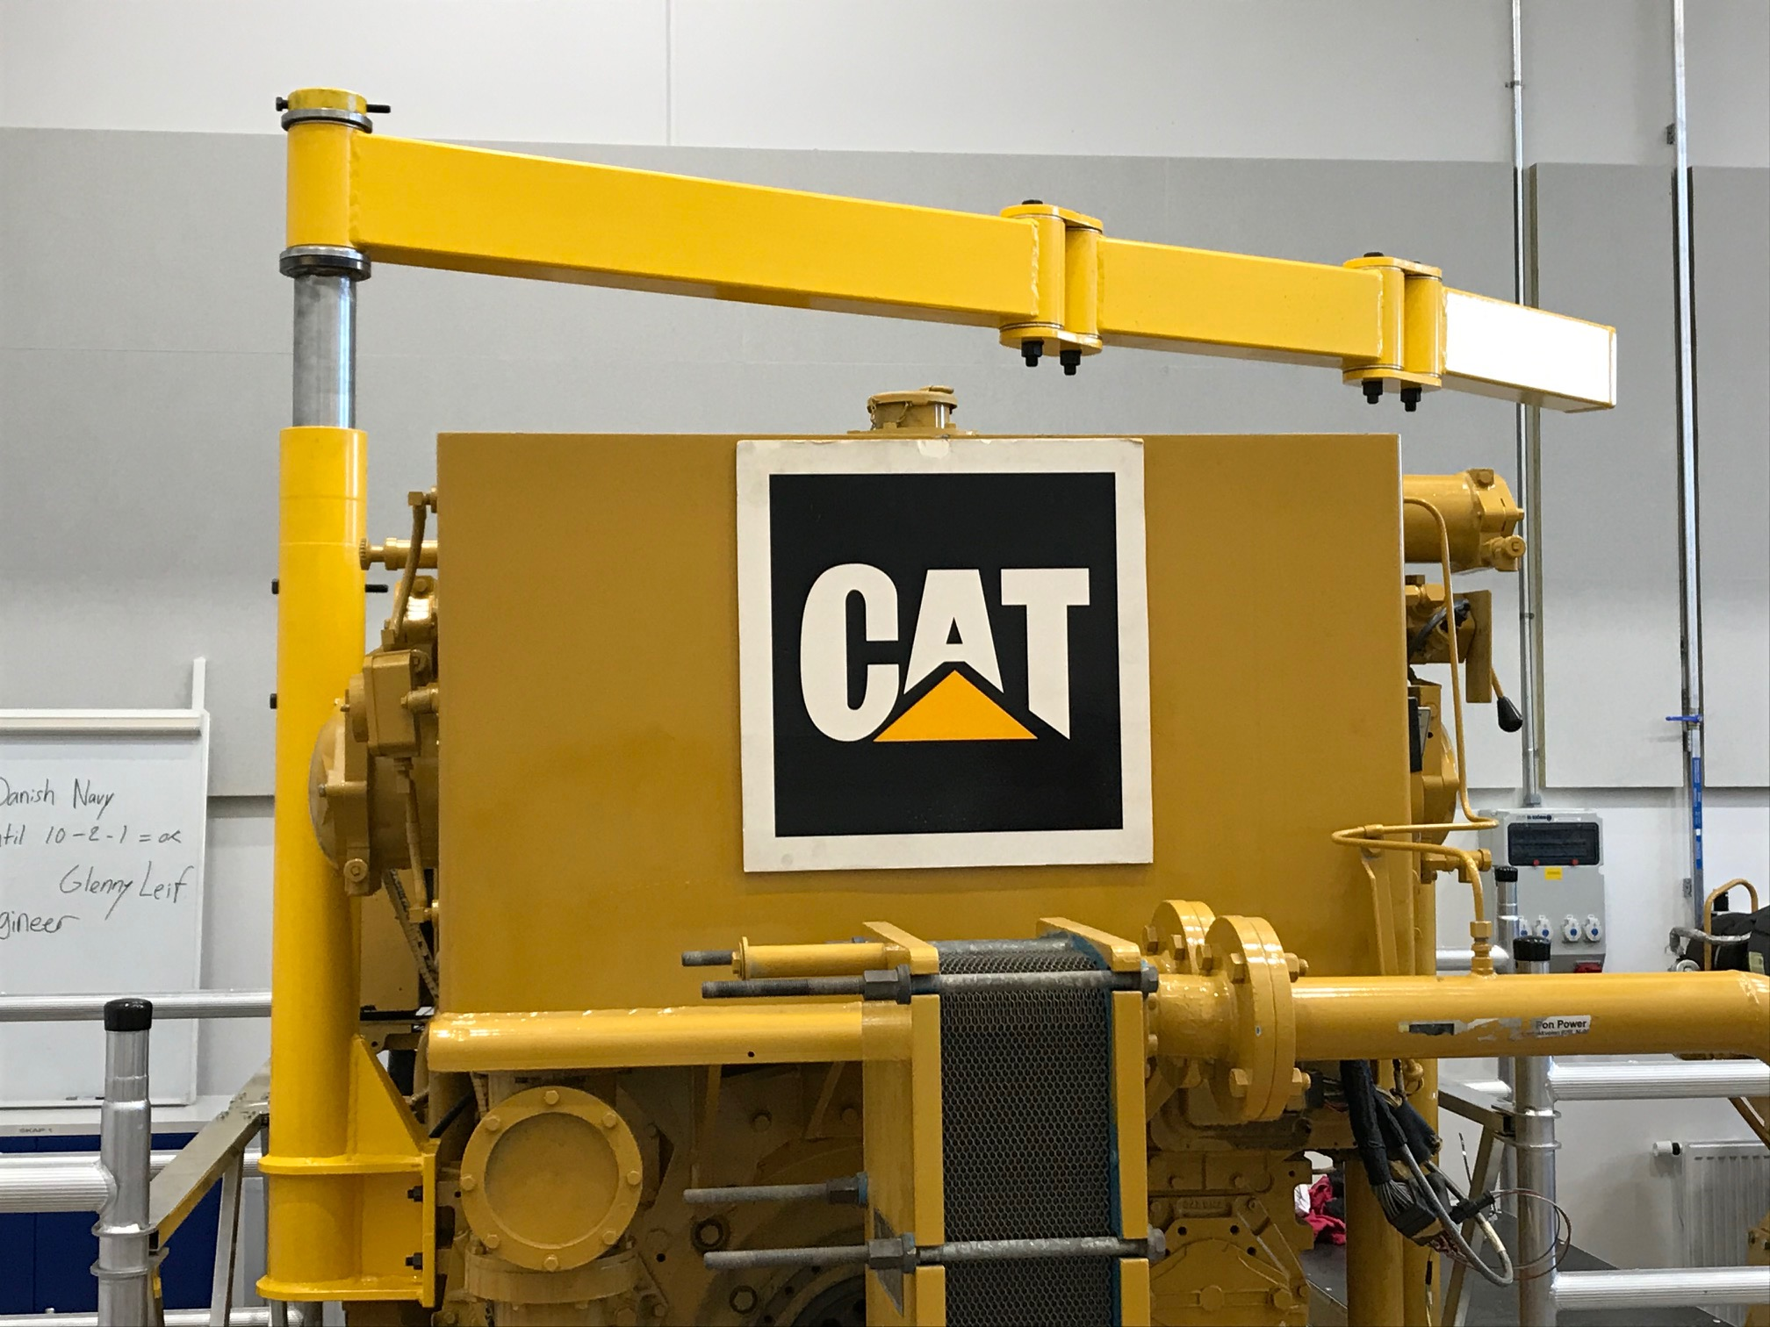

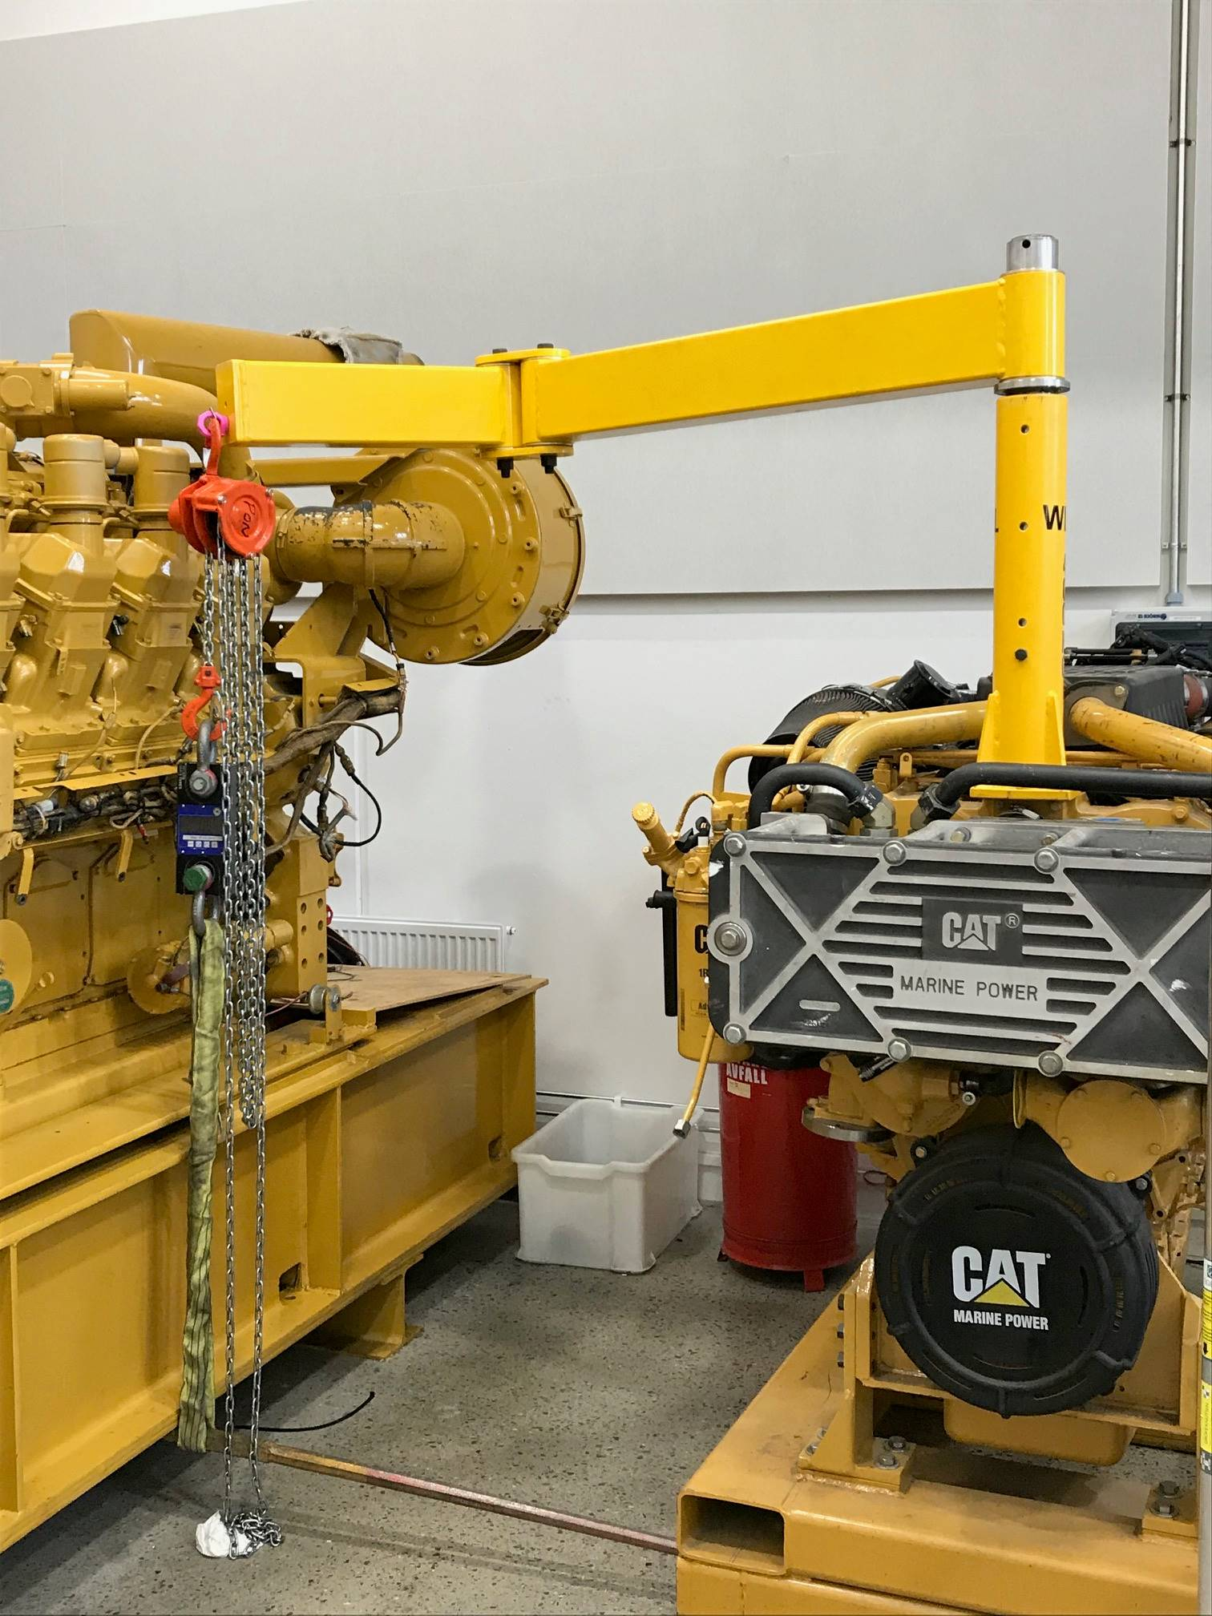C32 front mounting

